set statistics io on
SELECT DISTINCT SAC_RF_OPERACAO.CLCLI_CD, SAC_RF_LASTRO_REAL.DT_EMISSAO, SAC_RF_OPERACAO.RFLAS_CD_ADELIC, SAC_RF_OPERACAO.RFTP_CD_ADELIC, SAC_RF_LASTRO_REAL.VL_PU_EMISSAO FROM SAC_RF_OPERACAO, SAC_RF_MOV, SAC_RF_LASTRO, SAC_RF_LASTRO SAC_RF_LASTRO_REAL, BAS_CAD_CONTROL, CLI_BAS, BAS_CAD_IF, SAC_RF_EVENTO WHERE ( SAC_RF_OPERACAO.CLCLI_CD IN ('PRE','06062A','07061','1007','1061','1062','1064','55000','RFBD2')) AND ( SAC_RF_EVENTO.DT = '4-13-2012 0:0:0.000' ) AND ( SAC_RF_EVENTO.DT > SAC_RF_LASTRO.DT_EMISSAO ) AND ( SAC_RF_EVENTO.DT < SAC_RF_LASTRO.DT_VENCIMENTO ) AND ( SAC_RF_OPERACAO.CD = SAC_RF_MOV.RFOP_CD ) AND ( SAC_RF_OPERACAO.RFLAS_CD = SAC_RF_LASTRO.CD ) AND ( SAC_RF_LASTRO.IC_ADLIC = 'S' ) AND ( SAC_RF_OPERACAO.CLCLI_CD = CLI_BAS.CODCLI ) AND ( CLI_BAS.CD_CONTROL = BAS_CAD_CONTROL.CD ) AND ( ISNULL(BAS_CAD_CONTROL.CNPJ, ' ') <> ISNULL(BAS_CAD_IF.NO_CGC, ' ') ) AND ( SAC_RF_MOV.CD_LIQUIDANTE = BAS_CAD_IF.CODINST ) AND ( SAC_RF_MOV.SG_OPERACAO = 'C' ) AND ( SAC_RF_OPERACAO.RFLAS_CD_ADELIC = SAC_RF_EVENTO.RFLAS_CD ) AND ( SAC_RF_LASTRO_REAL.CD = SAC_RF_OPERACAO.RFLAS_CD_ADELIC )
set statistics io off

Table 'SAC_RF_LASTRO'. Scan count 1, logical reads 3824

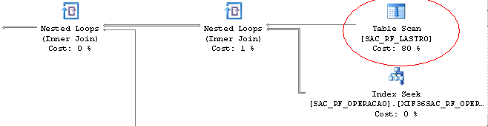

create index X2E1SAC_RF_LASTRO on SAC_RF_LASTRO(IC_ADLIC)
include (DT_VENCIMENTO,DT_EMISSAO,CD)

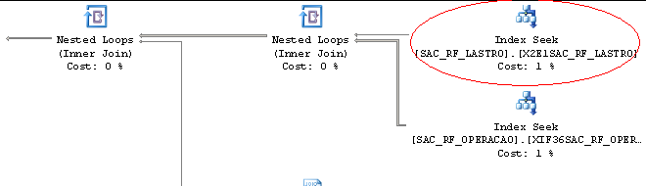

After creating the new index, the io dropped to:

Table 'SAC_RF_LASTRO'. Scan count 1, logical reads 2

